Project

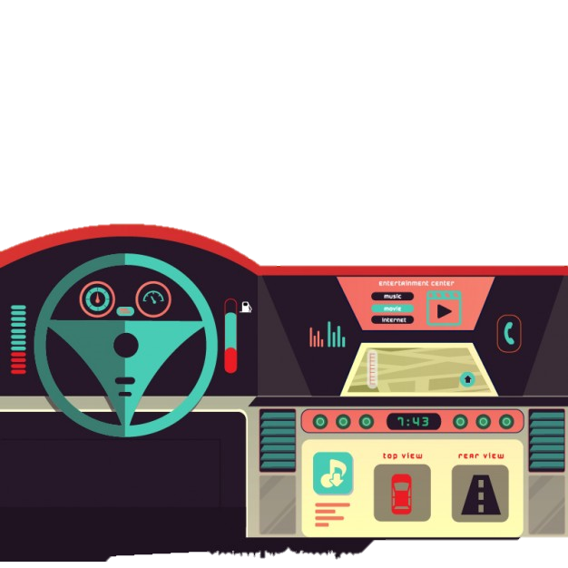AutOS

**Grupo 6:**

Fábio Magalhães – A75030

Rui Carvalho – A76279

Index

Problem Statement 3

Constraints 3

Technical Constraints 3

Functional Requirements 4

Non-Functional Requirements 4

System Overview 5

Gantt Chart 6

Problem Statement

All recent automobiles have an on-board computer, that assist the driving and the maintenance of the vehicle. It has become an accessory more and more indispensable, however it is still very expensive for the masses. Yet possible to install on older vehicles, it brings mechanical complications, and great monetary cost.

The Project’s goal is to develop an efficient, plug-n-play, inexpensive, functionality full on-board computer. I will be perfect companion to every road trip.

Apart from giving every basic information, the system will be able to report to the user every malfunction in the car.

Constraints

* Budget must be minimal.
* Project developed by a team of two.
* Pretty design

Technical Constraints

* Raspeberry Pi 3 Model B
* Buildroot
* Pthreads
* C/C++ programming language

Functional Requirements

* Get car information through OBD port
* Show data on screen
* Alert the user for malfunctions
* Calculate road slope
* Warn bad driver behaviour

Non-Functional Requirements

* Low Cost and low power.
* User-friendly interface.
* Plug’n’play
* Low latency.
* Soft Real-time

Software Specification

* Embedded Linux
* C/C++ Language
* Buildroot

System Overview

Hardware Overview

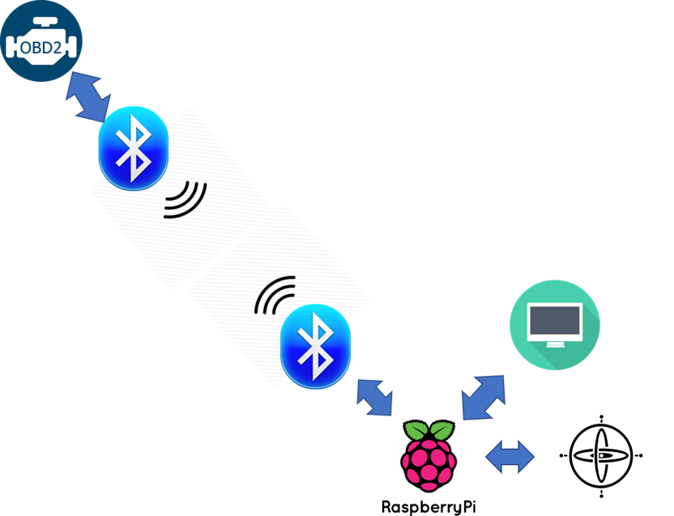

Software Overview

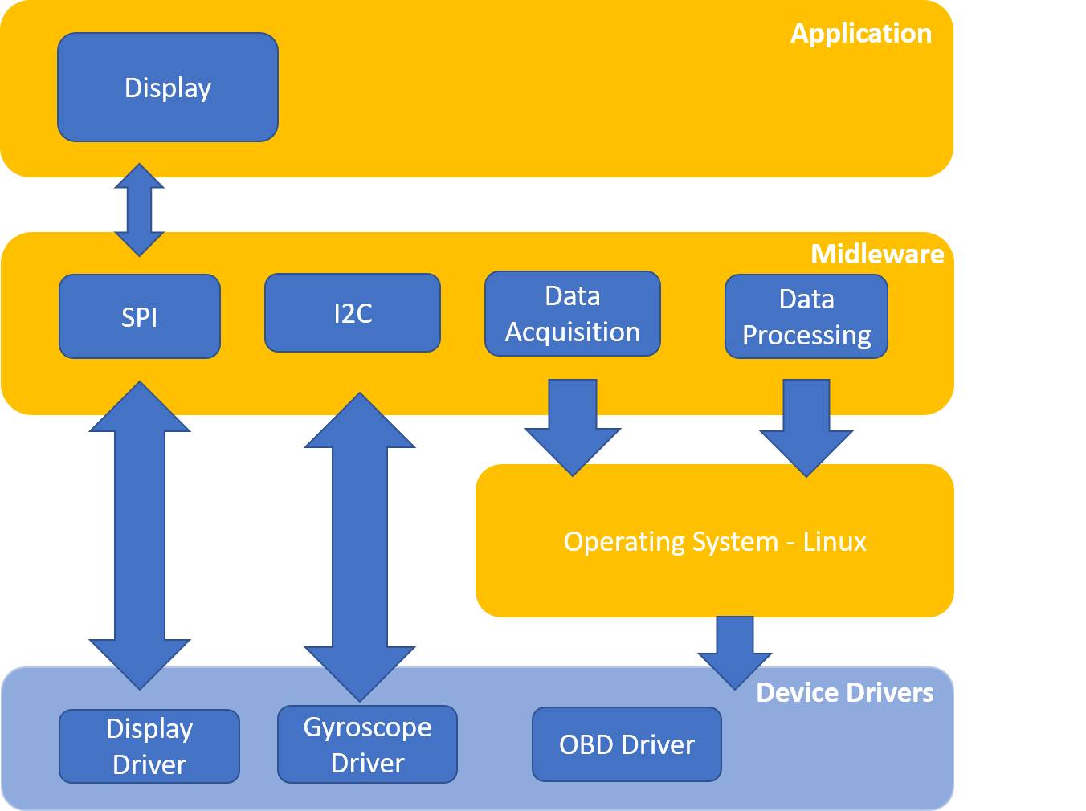

Gantt Chart

|  |  |
| --- | --- |
|  | Fábio Magalhães |
|  | Rui Carvalho |

